Odyssey Card Preview: Hallowed Healer
Gary Wise
Those of you who have been around long enough to remember when Standard and Limited were both being dominated by Morphling and Masticore must remember Sanctum Custodian. No? Come on, you remember: it was the easy-to-cast 1/2 that began the pattern we've seen over the last few years that has seen common damage prevention-capable creatures become dominant.
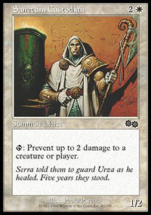
Well wait one minute, you're saying. The closest thing to a dominant common damage prevention-capable creature in Invasion block was Raka Disciple, and it was hardly dominant. Thing is, Invasion was hardly your run-of-the-mill Limited block, and with things getting back to normal in Odyssey, it's time to introduce the creature that will pick up the baton carried by Sanctum Custodian, Field Surgeon and Troubled Healer.
Ladies and Gentlemen: presenting Hallowed Healer.
In a set with two major abilities that are geared towards the long game, this is an early game card that maintains its value through the midgame before becoming even more powerful later on. Early game cards that maintain their value throughout are few and far between: In other words, when you get this little guy, you celebrate.
The card Hallowed Healer is most similar to is Sanctum Custodian, the common healer from Urza's Block (card for card the most powerful Block ever) that, barring a Pestilence or a powerful rare necessitated your drafting white. The Custodian wins out in the comparing of toughness, but the strength of the cards it was being played against and the power of the Healer's threshhold ability cancel out that slight advantage and then some.
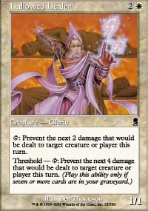
The power of the Healer can be found not so much in the actual activation so much as the potential for activation. When you attack with a 2/2 with the Healer out, your opponent should not block with their 2/2 as the result will likely be the trading of their 2/2 for the momentary tapping of your Healer. As a result, the mere presence of the Healer allows your 2/2 to go unblocked, while it remains untapped to remain on defense. It's the suggestion that makes this card so powerful.
When used for defensive purposes, the Healer is incredible. Think about this: if your opponent has three 3/3 creatures to your Healer and a 2/3, they can't attack unless they're willing to lose permanents in the exchange. Again, the threat of the Healer being activated after damage is on the stack will more often than not be devastating, making an attack impossible.
In addition to early sporadic combat, the Healer will often allow for the mass attack to not leave it's controller high and dry as per normal. The existence of a damage prevention source will force your opponent to do more gang blocking than normal if your opponent really wants particular creatures removed from play.
Now, you take all this usefulness and roll it up into one card any you obviously have a great Limited card, but we haven't even discussed the importance of the threshold ability. Simply put, cards with threshold abilities, more often than not, will allow for the dominating of the late game, but here we have a card that not only does that, but also gets you to the late game if you so desire. More than anything, Hallowed Healer will excel at freezing the game up when you want it to, getting you to the point where threshold will activate, in turn making the Healer stronger.
Think about how much four points of damage is. Applying it to Invasion Block, Duskwalker, Serpentine Kavu and Faerie Squadron each attack for zero, Flametongue Kavu, Urza's Rage and Scorching Lava won't kill a Kobold, and Tribal Flames will only kill that Kobold if you have all five basic land types in play. That's a lot of limitations on a lot of powerful cards.
Any time a creature card can mimic a spell ability with the cost being as simple as 'tap', it's bound to be a powerful card. The threat of this kind of power makes the Healer a must-kill card which, if not dealt with quickly, will allow the game to get completely out of hand.
The one real drawback of Hallowed Healer is that it just isn't well suited to Constructed play. It's fragile, too defensive and too slow. It's conceivable that it may see some sideboard action in Block, as other defensive white creatures like Field Surgeon have in the past, but more realistically it will probably be looked at for a moment and then rightfully discarded. Decks using the Healer for competitive purposes should be Limited to 59 cards or less.
So there you have it. What Sanctum Custodian began, Hallowed Healer continues, and should do so in fine fashion. When you sit down for that first side draft or Prerelease sealed deck, if you open the Healer, pump the fist and do a little dance: You've just opened a winner, as have those who came before you.

